
FRESH TEACHER'S E-LIBRARY
BEGINNING OF TERM III EXAMINATION 2023
PRIMARY ONE
LITERACY 1A

My name is __________________________________________

I am in ______________________________________________

My school is _________________________________________
SECTION A:
- What do hens give us?
_______________________________________________________
- Give one way of caring for our hair.
_______________________________________________________
- Name two types of weather.
- ___________________________________________________
- ___________________________________________________
- Where do these animals live?
- Fish ______________________________________________
- Lion ______________________________________________
- Why do we boil water for drinking?
_______________________________________________________
- Name one member of a nuclear family?
_______________________________________________________
- Draw this food stuff we eat at school.
mango

- Name one item people make from clay.
_______________________________________________________
- Name these activities we do at home.
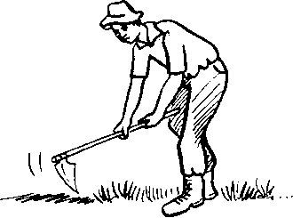 | 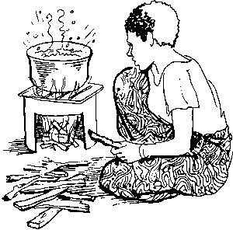
- Write one effect of accidents to people.
_______________________________________________________
- Give one role of a doctor in our community.
_______________________________________________________
- Give two ways of caring for domestic animals at home.
- ___________________________________________________
- ___________________________________________________

- How are these garden tools useful to people?
Garden tool | Use
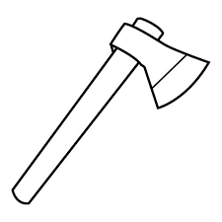 | _____________________________________
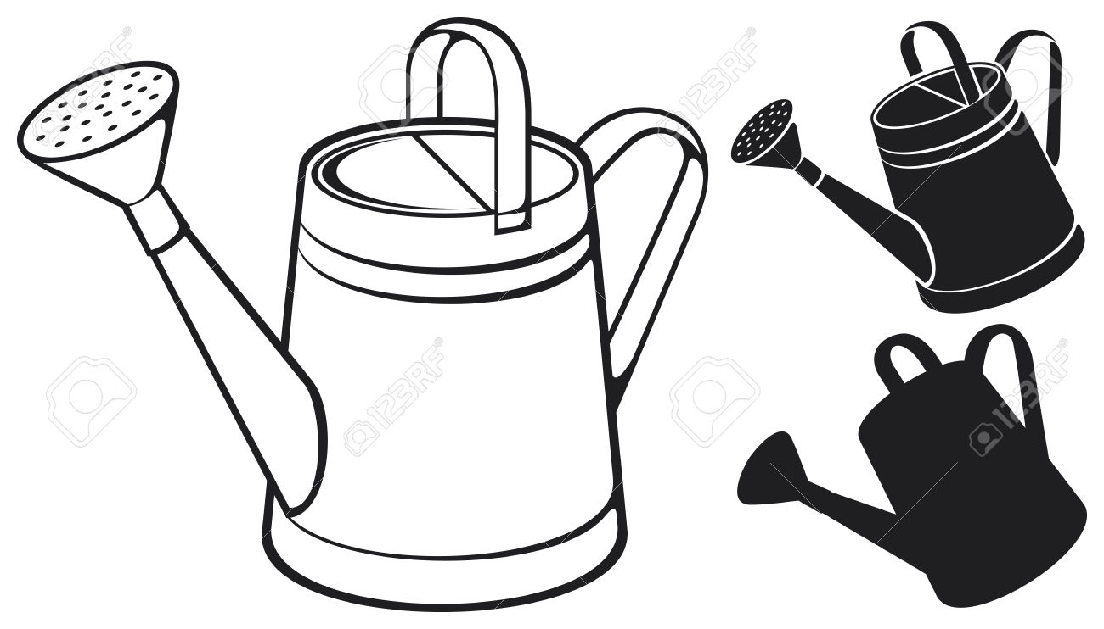 | ____________________________________

- Write one way people keep toilets clean.
_______________________________________________________
- In which season do farmers dry seeds?
_______________________________________________________
SECTION B:
- a) Name these things children make.
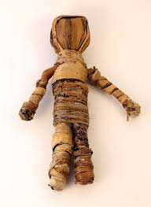 | 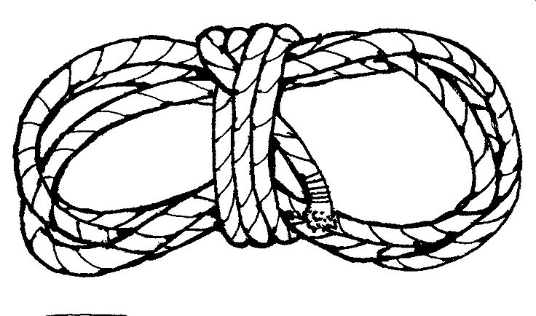

b) Give one material children can use to make balls.
___________________________________________________
- a) Name two objects that can cut people.
- ___________________________________________________
- ___________________________________________________
b) Give one common accident at school.
___________________________________________________
- Draw these items people use to manage weather.
gumboots | umbrella
- Write two ways of caring for our clothes.
- ___________________________________________________
- ___________________________________________________
- a) Name this plant we grow in our gardens.
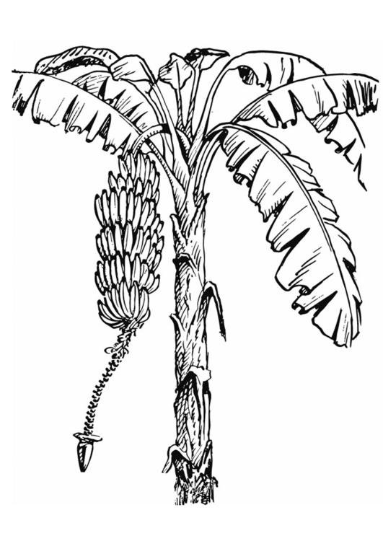
A

___________________________________________________
b) Name the part of the plant marked A.
___________________________________________________
- Give two uses of plants to people.
- ___________________________________________________
- ___________________________________________________
- a) Write two ways of preserving food.
- ___________________________________________________
- ___________________________________________________
- Give two reasons why people eat food.
- ___________________________________________________
- ___________________________________________________
- a) Name the insect that gives us honey.
___________________________________________________
b) Name one insect that spreads diseases to people.
___________________________________________________
- Match the organs to their senses.
Organ Sense
  - Tongue feeling
  - Ears seeing
  - Skin hearing
  - Eyes tasting
- Tongue _____________________________________
- Ears _____________________________________
- Skin _____________________________________
- Eyes _____________________________________
- a) Name two rooms found in a good house.
- ___________________________________________________
- ___________________________________________________
b) Name these items we use to clean our home.
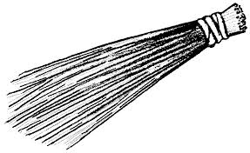 | 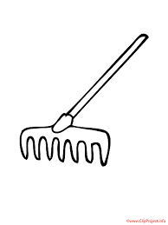
****************** END ******************

